**Configuration management plan**

[Name of Project]

**Contents**

**List of table** 2

**1.** **Revision** 3

**2.** **Introduction** 4

2.1. Purpose 4

2.2. Audience 4

**3.** **Configuration Activities** 5

3.1. Organization 5

3.2. Configuration management responsibilities 5

3.3. General Guidelines 5

3.4. Configuration control 5

3.5. Configuration Identification 5

3.6. Tools 5

**4.** **Naming convention** 6

4.1. Documentation 6

a. Project management: 6

**5.** **Admission system depository** 8

5.1. Directory structure 8

**6.** **Code standard** 9

# **List of table**

Table 1: Revision history 3

Table 1 Name for project management 6

Table 2 Name for Requirement phase 6

Table 3 Name for Design phase 6

Table 4 Name for Code phase 7

Table 5 Name for Test phase 7

Table 6 Name for Time log 7

Table 7 Name for Presentation 7

Table 8 Name for Meeting minute 7

# **Revision**

|  |  |  |  |  |
| --- | --- | --- | --- | --- |
| **No** | **Version** | **Update date** | **Author** | **Content** |
| 1 | 1.0 | 06/11/2013 | Ta Ngoc Thien Phu | Create Document |
| 2 | 1.1 | 16/11/201 | Le Ngoc Chau | Update time log’s name |

Table 1: Revision history

# **Introduction**

## Purpose

[Description purpose of document]

## Audience

[Description audience of document]

# **Configuration Activities**

## Organization

[Description about organization where support for implement configuration management]

## Configuration management responsibilities

[Description about responsibilities of person who implement configuration management]

## General Guidelines

[Description general guidelines for activities of configuration management]

## Configuration control

## Configuration Identification

Team manages followings as configuration items.

* SRS (Software Requirement Specification)
* SCMP (Software Configuration Managements Plan)
* CMB (Change Management Plan)
* RMP (Risk Management Plan)
* STS (System Test Specification)
* STP (System Test Plan)
* Source Code

## Tools

* Microsoft Office 2013
* Eclipse
* Maven 2
* MySQL
* SVN

# **Naming convention**

## Documentation

## Project management:

|  |  |  |
| --- | --- | --- |
| **No** | **The file type** | **The file name** |
| 1 | File: | AS_PM_FileName. |
| Example: AS_PM_MeasurementPlan |
| 2 | Report file: | AS_PM_WeeklyReport_Name |
| Example: AS_PM_ WeeklyReport_HuyNgo |
| 3 | Work detail file: | AS_PM_DailyReport_#?  *\*#?: day* |
| Example: AS_PM_DailyReport_281113 |
| 4 | Weekly report file: | AS_PM_WeeklyReport_PhaseName_#?  *\*#?: day* |
| AS_PM_WeeklyReport_Requirement_281113 |
| 5 | Weekly evaluation file: | AS_PM_WeeklyEvaluation |
| Example: AS_PM_WeeklyEvaluation |

Table 1 Name for project management

* 1. Requirement phase

|  |  |  |
| --- | --- | --- |
| **No** | **The file type** | **The file name** |
| 1 | File: | AS_RE_filename  Example: AS_RE_OperationRequirement |
| 2 | Report file: | AS_RE_Report_Name |
| 3 | Work detail file: | AS_RE_WorkDetail_Week#?  *\*#?: Number of week* |
| 4 | Weekly report file: | AS_RE_WeeklyReport_Name |

Table 2 Name for Requirement phase

* 1. Design phase

|  |  |  |
| --- | --- | --- |
| **No** | **The file type** | **The file name** |
| 1 | File | AS_AD_filename  Example: AS_AD_ArchitectureDriver |
| 2 | Report file | AS_AD_Report_Name |
| 3 | Work detail file | AS_AD_WorkDetail_Week#?  *\*#?: Number of week* |
| 4 | Weekly report file | AS_AD_WeeklyReport_Name |
| 5 | Daily report file | AS_AD_DailyReport_Name_#?  *\*#?: day* |

Table 3 Name for Design phase

* 1. Code phase

|  |  |  |
| --- | --- | --- |
| **No** | **The file type** | **The file name** |
| 1 | File: | AS_IM_FileName  Example: AS_IM_SourceCode |
| 2 | Report: | AS _ IM _Report_Name |
| 3 | Work detail file: | AS_IM_WorkDetail_Week#?  *\*#?: number of week* |
| 4 | Weekly report file: | AS_IM_WeeklyReport_Name |
| 5 | Daily report file | AS_IM_DailyReport_Name_#?  *\*#?: day* |

Table 4 Name for Code phase

* 1. Test phase

|  |  |  |
| --- | --- | --- |
| **No** | **The file type** | **The file name** |
| 1 | File: | AS _TE_FileName |
| 2 | Report: | AS _TE_WeeklyReport_ImplementationName |
| 3 | Work detail file: | AS _TE_WorkDetail_Week#?  *\*#?: number of week* |
| 4 | Weekly report file: | AS _TE_WeeklyReport_ImplementationName |
| 5 | Weekly evaluation file | AS _TE_Evaluation_Week#?  *\*#?: number of week* |

Table 5 Name for Test phase

* 1. Time log

|  |  |  |
| --- | --- | --- |
| **No** | **The file type** | **The file name** |
| 1 | File chung | AS_PM_DeadlineTeam_TimeLog |
| 2 | Time log actual | AS_PM_TimeLog_DeadlineTeam _Name  Example: AS_PM_TimeLog_DeadlineTeam_PhuTa  *\*#?: number of effort log* |

Table 6 Name for Time log

* 1. Presentation

|  |  |  |
| --- | --- | --- |
| **No** | **The file type** | **The file name** |
| 1 | File | AS_DeadlineTeam_FileName.ppt |

Table 7 Name for Presentation

* 1. Meeting minute

|  |  |  |
| --- | --- | --- |
| **No** | **The file type** | **The file name** |
| 1 | File | AS_PM_Meeting_Minutes_ddmmyy_#?  Example: AS_PM_Meeting_Minutes_121113_01  *\*If we have only 1 meeting, “#?” needn't to fill*  *\*If we have more than 1 meeting, “#?” to be replaced by 1 or 2...* |

Table 8 Name for Meeting minute

# **Admission system depository**

## Directory structure

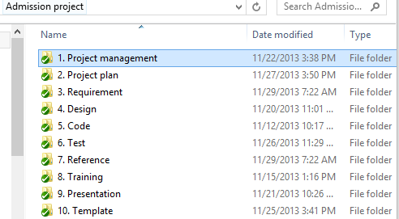

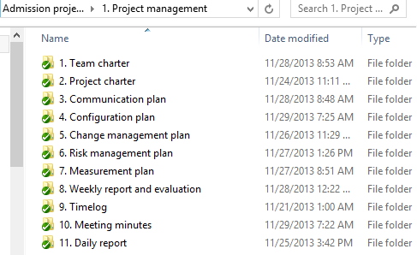

# **Code standard**

N/A